**GOVERNMENT GRADUATE COLLEGE OF SCIENCE, WAHDAT ROAD LAHORE**



**ASSIGNMENT:**

Analytical Chemistry (Sp-Theory-1)

**TOPIC:**

Thermo-Gravimetric Analysis (TGA)

**Class:**

BS Chemistry semester 7th

**SUBMITTED TO:**

Dr. Naeem Khan

**SUBMITTED BY:**

M. Zahid Rashid (172)

Hassam Ahmad (181)

Haris Iqbal (187)

M. Haseeb (158)

**Thermo-Gravimetric Analysis**

* **Introduction:**

When matter is heated, it undergoes two types of changes,

1. Physical changes
2. Chemical changes

* **Physical changes:**
* Physical changes involve the phase changes such as melting, vaporization, crystallization, transitions between crystal structures, changes in microstructure in metal alloys and polymers, volume changes and changes in mechanical behavior.
* **Chemical changes:**
* Chemical changes include chemical reactions to for new products, oxidation, corrosion, decomposition, dehydration etc.
* These physical and chemical changes take place over a wide range of temperature. So it is necessary to characterize the materials and their behavior over a range of temperature to determine what materials are suitable for specific uses and to determine what temperature range materials or chemicals can withstand without changing.
* This sort of information is used to predict the safety conditions for products, such as which type of type material is suitable for vehicles in extremely hot and extremely cold climates.
* **Principle of TGA:**
* Thermo-gravimetric analysis measures the mass of a sample as it is heated, cooled or held at constant temperature in a defined atmosphere.
* When a substance is heated its mass may be decreased or increased through various steps. Thermal analysis of a polymer is studied in below figure which show different processes at different temperatures which cause change in weight of polymer.

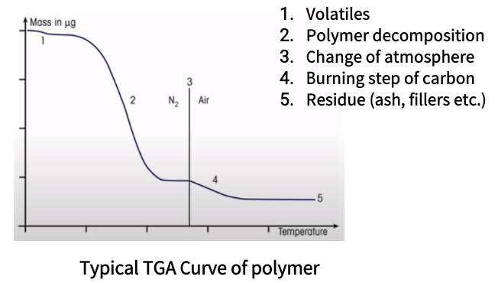

* **Types of Thermo-Gravimetry:**

There are three types of thermo-gravimetry which are explained below

* **Isothermal thermo-gravimetry:**

In this technique the sample weight is recorded as function of time at constant temperature.

* **Quasi Static thermo-gravimetry**:

In this technique the sample is heated to constant weight at each of series of increasing temperatures.

* **Dynamic thermo-gravimetry**:

In this technique the sample is heated in an environment whose temperature is changing in a predetermined manner generally at linear rate.

* **Instrumentation of TGA:**

The thermo-gravimetric analysis measures the mass changes of a sample at different ranges of temperatures. The working system of TGA consist on following components,

* Balance
* Sample Holder
* Furnace
* Temperature programmer/controller
* Recorder

1. **Balance:**

The balance should have following requirements,

* It must be Sensitive, accurate and reproducible.
* It must has rapid response to weight changes.
* It must has adequate range of automatic weight adjustments.
* It must has high degree of mechanically or electronically stability.
* It should not affected by vibrations, simple to operate and versatile.
* **Types of balances:**

Two types of balance are used according to requirements.

1. Deflection balance
2. Null-point balance
3. **Deflection balance:**

Deflection balances are of four types are used

1. Beam type balance
2. Spring type balance
3. Cantilever type balance
4. Torsion type balance

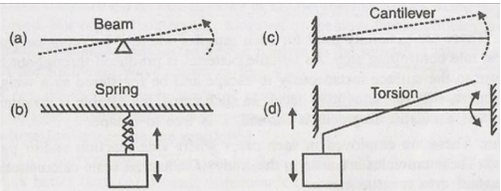

1. **Null-point balance:**

* It consists on a sensor which detects deviation from the null point and restores the balance to its null points by means of restoring force.

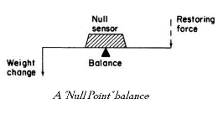

* **Working principle of balance:**
* The balance operates on a null-balance principle. At the zero position equal amounts of light shine on the two photodiodes.
* If the balance moves out of the null position an unequal amount of light shines on the two photodiodes. Current is applied to meter movement to return the balance to the null position.
* The amount of current applied is proportional to the weight changes (loss or gain) of sample.

1. **Sample holder:**

* The sample to be studied is placed in a sample holder or crucible.
* It is attached to weighing arm of microbalance.
* There are different varieties of crucibles used. Some differ in shape and size while some differ in materials used.
* They are made up from platinum, aluminum, quartz or alumina or some other materials like graphite, stainless steel and glass etc
* **Crucibles:**
* Crucibles should have temperature at least 100k greater than temperature of experiment and must transfer uniformly heat to sample. Therefore the shape, thermal conductivity and thermal mass of crucibles are important which depends upon the weight and nature of sample and temperature range.

There are different types of crucibles are used,

1. Shallow pans (used for volatile substances)
2. Deep crucibles (industrial scale calcinations)
3. Loosely covered crucibles ( self-generated used for atmosphere studies)
4. Retort cups (used for boiling point studies)
5. **Furnace:**

* The furnace should be designed in such a way that it should produce linear heating rate.
* It should have a hot zone which can hold sample and crucible and its temperature corresponds to the temperature of furnace.
* There are different combinations of microbalance and furnace are available. The furnace heating coil should be wound in such a way that there is no magnetic interaction between coil and sample.

1. **Temperature programmer/controller:**

* The measurement of temperature is done in a number of ways, thermocouple is most common technique.
* The position of temperature measuring device relative to sample is very important.
* **Major types:**

1. The thermocouple is placed near the sample container but it has no contact with sample container. This is not good arrangement where low pressures are employed.
2. The sample is kept inside the sample holder but it has no contact with sample. This arrangement is better because it responds small temperatures changes.
3. The thermocouple is placed either in contact with sample or sample container. This is good arrangement for sample temperature detection.
4. **Recorder:**

The recorder system of mainly two types used,

1. Time-base potentiometric strips recorder
2. X-Y recorder

* In some instruments light beam galvanometer, photo-graphic paper recorders or one recorder with two or more pens are used.
* In X-Y recorder, we get curves having plot of weights directly against temperatures.
* However, the percentage mass change against temperature or time would be more useful.

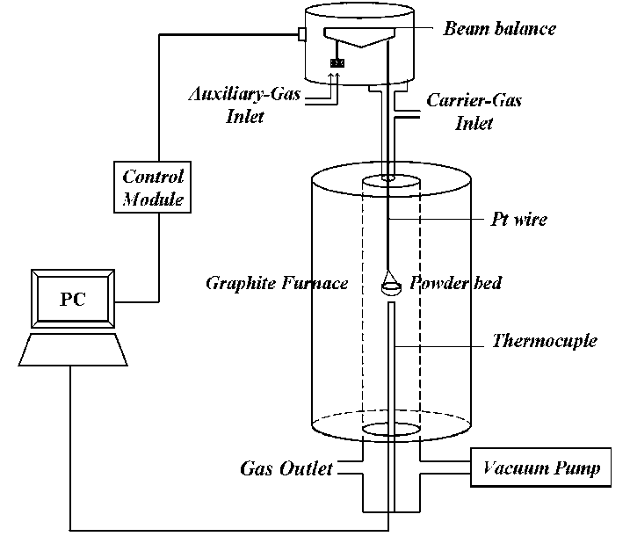

Schematic diagram of TGA instrument:

* **Applications of TGA:**

Thermo-gravimetric analysis provides information about following applications;

* Thermal and oxidative stability of materials
* Purity of materials
* About kinetics of solid state reactions
* Decomposition of inorganic and organic compounds
* Determining composition of mixtures
* Corrosion of metals on different atmosphere
* Pyrolysis of coal, petroleum and wood
* Roasting and calcinations of materials
* Reaction kinetics studies
* Evaluation of gravimetric precipitates
* Oxidative and reductive stability
* Determining moisture, volatile and ash contents
* Desolvation, sublimation, vaporization, sorption and desorption etc
* Estimated life time of materials

____________________________________________